Deerwalk Institute Of Technology
Database Administration

Lab:

Submitted By: Submitted To:
Name: Sagar Giri Narayan Chalise
Roll No. 205

Date:
Triggers
Triggers are stored programs, which are automatically executed or fired when some events occur. Triggers are, in fact, written to be executed in response to any of the following events:

- A database manipulation (DML) statement (DELETE, INSERT, or UPDATE).

- A database definition (DDL) statement (CREATE, ALTER, or DROP).

- A database operation (SERVERERROR, LOGON, LOGOFF, STARTUP, or SHUTDOWN).

Triggers could be defined on the table, view, schema, or database with which the event is associated.

Syntax:
CREATE [OR REPLACE ] TRIGGER trigger_name
{BEFORE | AFTER | INSTEAD OF }
{INSERT [OR] | UPDATE [OR] | DELETE}
[OF col_name]
ON table_name
[REFERENCING OLD AS o NEW AS n]
[FOR EACH ROW]
WHEN (condition)
DECLARE
Declaration-statements
BEGIN
Executable-statements
EXCEPTION
Exception-handling-statements
END;

Exercise to calculate salary differences among employees while updating a record:
Lets consider we have following table:
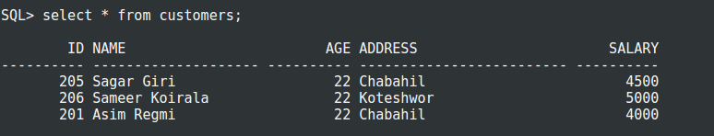

Now, we write our trigger and execute:
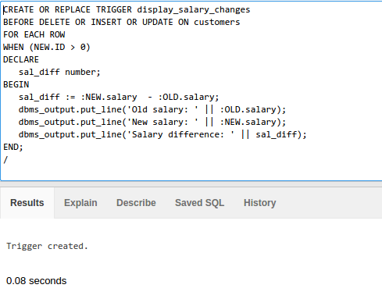

Now when we insert any record a trigger is fired.
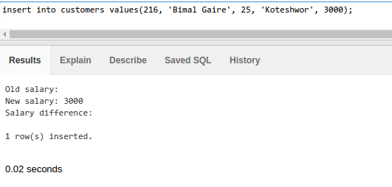
Also, while updating:
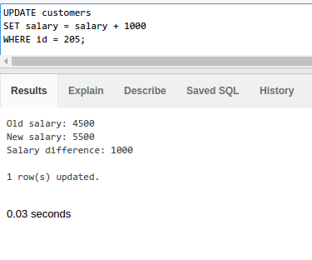

Another trigger which change cases of entry in table while updating or inserting.
